
Name: …………….......……

Mathematics Methods, Year 12, 2018
Test 1 – Further differentiation and applications

Total | /27 | %

25 minutes working time.
Calculator Assumed Section (notes allowed)
SCSA Formula sheet and calculators allowed

8. [9 marks: 3, 6]
A closed cylindrical can of radius r cm has a volume of 250𝜋 cm³.
a) Show that the total surface area, A cm², of this can is given by $A=\frac{500π}{r}+2πr^{2}$.

b) Use derivatives to determine the minimum possible total surface area of the can, justifying that it is a minimum, and state the radius and height required to achieve this minimum area

9. [10 marks: 1, 4, 5]
The displacement, in centimetres, of a small body from a fixed point O after t seconds is given by $x(t)$ with $x\left(t\right)=(t-a)(2t^{2}-5t+2)$, where $a$ is a constant.
a) Show that the body is at O when $t=\frac{1}{2}$.

b) Given that the body has a velocity of 3 cm/s when $t=1$, determine the value of the constant $a$.

c) Determine the acceleration of the body when t > 0 and it has a velocity of 27 cm/s.

10 [8 marks: 2, 2, 4]
A polynomial function $f\left(x\right)=ax^{4}+bx^{2}+c$, where $a$, $b$ and $c$ are real constants, has the following features:

- $f\left(x\right)=0$ only for $x=-2$ and $x=2$
- $f^{'}\left(x\right)=0$ only for $x=-1$, $x=0$ and $x=1$
- $f'(x)>0$ only for $-1<x<0$ and $x>1$
- $f''(0)<0$

a) At the point where the curve intersects the y-axis, is it concave up or concave down? Explain your answer.

b) Is $c$ positive or negative? Explain your answer.

c) Sketch a possible graph of the function on the axes below.

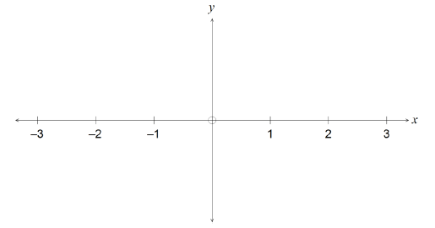

END OF TEST

